MACHINE LEARNING
3. Linear Models
3.1 The least-squares method, Multivariate Linear Regression, Regularized Regression, Using Least-Squares Regression for classification
3.2 Support Vector Machines
PAST QUESTIONS:
- The values of independent variable X and the dependent variable Y are given below. Find the least square regression line Y=aX+b. Estimate the Y when the value of X equals 10. (M23)
X | 0 | 1 | 2 | 3 | 4
Y | 2 | 3 | 5 | 4 | 6
- Write a short note on (a) Multivariate Regression and (b) Regularized Regression. (M23, D24)
- Least Square Regression for classification. (M23, D23, D24)
- Differentiate between Ridge and Lasso Regression. (M23, D23)
- Find a linear regression equation for the following two sets of data: (D23)
X | 3 | 5 | 7 | 9
Y | 12 | 18 | 24 | 30
- Discuss Support Vector Machines. (M24)
- Find a linear regression equation for the following two sets of data: (D24)
Time X in (Seconds) | 5 | 7 | 12 | 16 | 20
Mass Y in (Grams) | 40 | 120 | 180 | 210 | 240
- Short note on Ridge and Lasso Regression. (D24)
NOTES:

*Multivariate Regression :-
Multivariate Regression is one of the simplest Machine Learning Algorithm. It comes under the class of Supervised Learning Algorithms.
Multivariate regression is a technique used to measure the linear relationship between one or more independent variable and one or more dependent variable.
The relationship is said to be linear due to the correlation between the variables.
Independent variable – It is the variable used to make the prediction.
Dependent variable – It is the variable that we are trying to predict.
Advantages –
- It can predict more than one dependent variable at the same time.
- It shows how independent variables affect multiple outcomes together.
- The multivariate regression method helps you find a relationship between multiple variables or features.
- It also defines the correlation between independent variables and dependent variables.
Disadvantages –
- Multivariate regression technique requires high-level mathematical calculations.
- Multivariate regression yields better results when used with larger datasets rather than small ones.
- It is complex.
- The output of the multivariate regression model is difficult to analyze.

*Regularized Regression :-
Regularized regression is a regression method with an additional constraint designed to deal with a large number of independent variables (a.k.a. predictors). It does so by imposing a penalty on unimportant ones, thus shrinking their coefficients towards zero.
Regularized regression is an advanced form of linear regression that includes a penalty term to avoid overfitting and improve model generalization.
Types of Regularized Regression:
- Lasso Regression - A regression model which uses the L1 Regularization technique is called LASSO (Least Absolute Shrinkage and Selection Operator) regression. Lasso Regression adds the “absolute value” of the coefficient as a penalty term to the loss function(L).
- Ridge Regression - A regression model that uses the L2 regularization technique is called Ridge regression. Ridge regression adds the “squared magnitude” of the coefficient as a penalty term to the loss function(L).
- Elastic Net Regression - Elastic Net Regression is a combination of both L1 as well as L2 regularization. That implies that we add the absolute norm of the weights as well as the squared measure of the weights.
Advantages –
- It reduces overfitting by adding a penalty.
- It automatically eliminates irrelevant features by setting their coefficients to zero.
- Works well with high dimensional data.
- Performs better on unseen data compared to basic linear regression.
Disadvantages –
- Requires tunning of hyperparameter.
- Too much penalty can oversimplify the model leading to underfitting.

*Ridge vs Lasso Regression :-
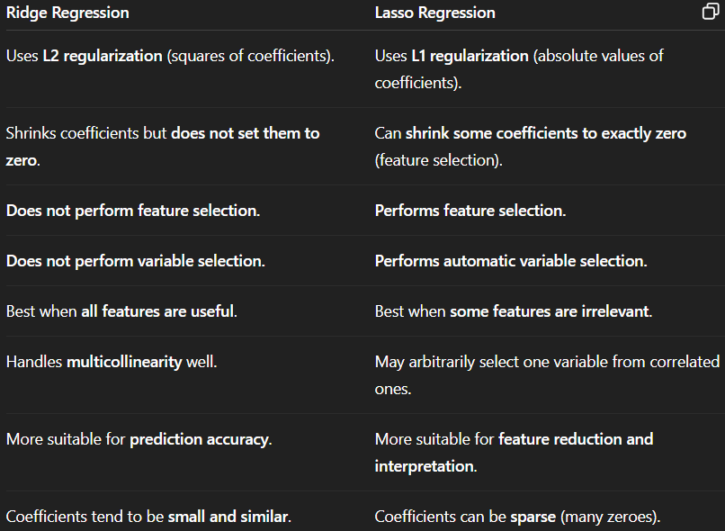

*Least Square Regression for Classification :-
Least Square Regression is a statistical method commonly used in machine learning for analyzing and modelling data. It involves finding the line of best fit that minimizes the sum of the squared residuals (the difference between the actual values and the predicted values) between the independent variables and the dependent variable.
Least squares regression, while traditionally used for predicting continuous outcomes. However, It can be adapted for classification using techniques like:
- Least Squares Classification (LSC)
- Least Squares Support Vector Machines (LS-SVM).
In these, the goal is to find a decision boundary that separates the classes while minimizing the sum of squared errors.
In classification, the goal is not to predict a continuous value, but to assign a data point to a class (e.g., 0 or 1). Least squares regression modifies its objective to make this possible.
A more robust version of least squares classification is LS-SVM, which uses:
- Sum of squared errors.
- Kernel trick for handling non-linear classification.
- Regularization to avoid overfitting.
Advantages –
- Simple and easy to implement.
- Can be used as a baseline model for classification.
- Works well when classes are linearly separable.
- LS-SVM handles non-linearity using kernel functions.
Disadvantages –
- Least square is sensitive to outliers.
- Predictions are not probabilistic.
- Can perform poorly in complex classification tasks.
- Not as robust as logistic regression or SVM in many cases.

*Support Vector Machine (SVM) :-
Support Vector Machine (SVM) is a supervised machine learning algorithm used for classification and regression tasks. While it can handle regression problems, SVM is particularly well-suited for classification tasks.
SVM aims to find the optimal hyperplane that best separates the two classes.
SVM does this by finding the maximum margin between the hyperplanes that means maximum distances between the two classes.
Both Logistic Regression & SVM algorithms try to find the best hyperplane, but the main difference is logistic regression is a probabilistic approach whereas support vector machine is based on statistical approaches.
Key terms –
- Support Vectors - These are the points that are closest to the hyperplane. A separating line will be defined with the help of these data points.
- Margin - It is the distance between the hyperplane and the observations closest to the support vectors.
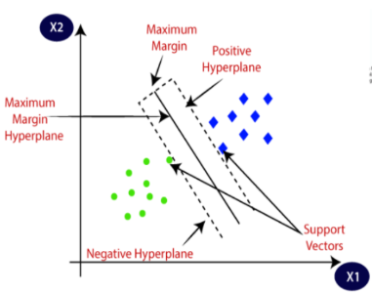
Types of SVM –
- Linear SVM - Linear SVMs use a linear decision boundary to separate the data points of different classes. When the data can be precisely linearly separated, linear SVMs are very suitable. This means that a single straight line (in 2D) or a hyperplane (in higher dimensions) can entirely divide the data points into their respective classes.
- Non-Linear SVM - Non-Linear SVM can be used to classify data when it cannot be separated into two classes by a straight line (in the case of 2D). By using kernel functions, nonlinear SVMs can handle nonlinearly separable data.
Advantages –
- SVM works better when the data is Linear.
- It is more effective in high dimensions.
- With the help of the kernel trick, we can solve any complex Problem.
- SVM is not sensitive to outliers.
- Can help us with Image classification.
Disadvantages –
- Choosing a good kernel is not easy.
- SVM can be slow for large datasets, affecting performance.

